Case Study Submission Template

- Name : Pitchu Nath N J

- Employee Id : 1432497

- Email Id : pitchunath.nj@tcs.com

- Your Git Repository URL : https://github.com/pitchunath/batch10.git ,https://github.com/pitchunath/git-demo-devops-training.git

- Attach the screenshot of your Dockerfile.

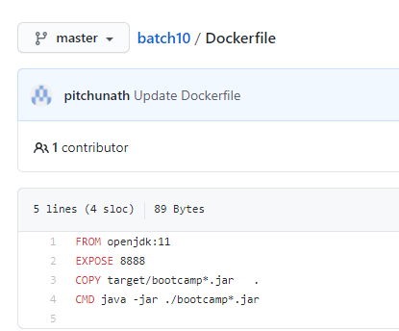

- Attach the screenshot of your Jenkinsfile.

https://github.com/pitchunath/batch10/blob/master/Jenkinsfile
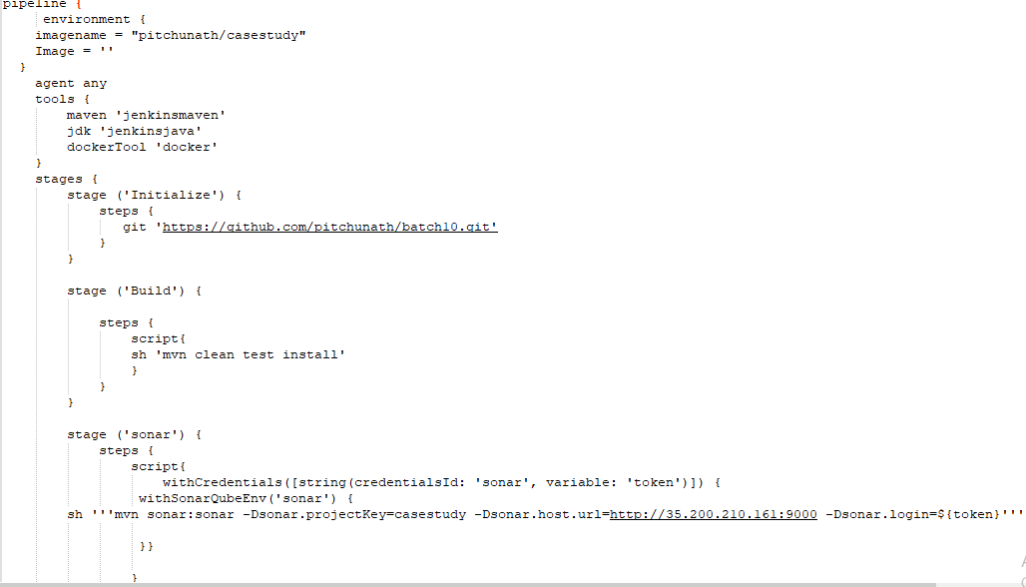
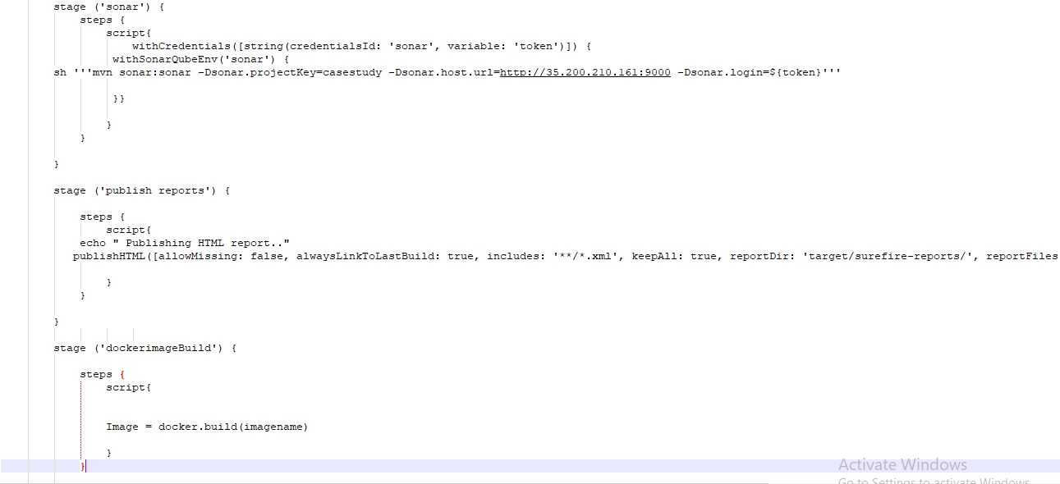
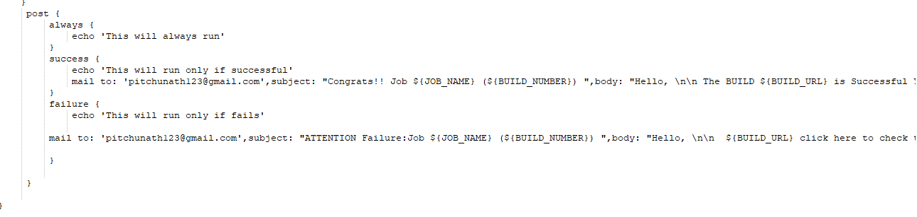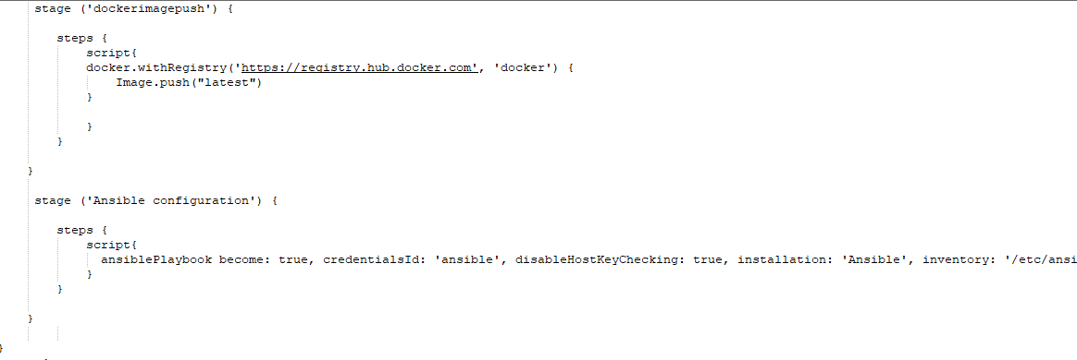

- Upload your Jenkins Log file in the Repo.(Complete log file should display your name on top).

https://github.com/pitchunath/git-demo-devops-training/blob/master/Jenkinslogforcasestudy

- Attach the screenshot of Jenkins pipeline job status. (All boxes should be green)
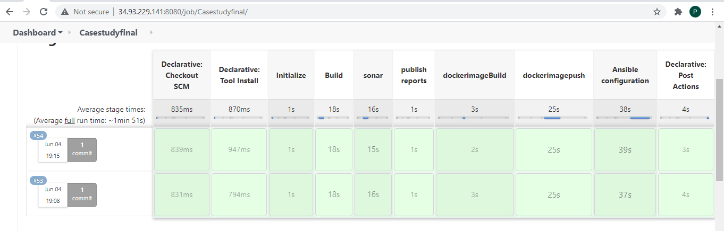

- Attach screenshots of email notification for the Jenkins build.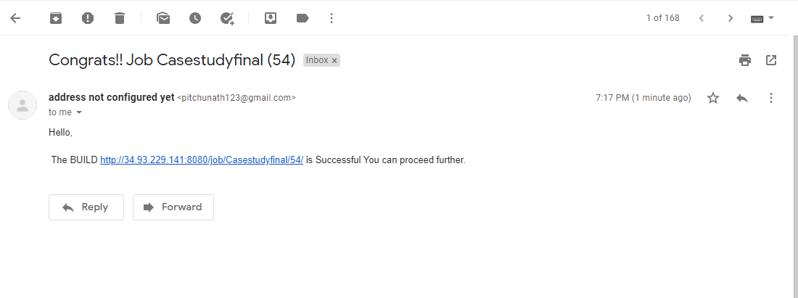

- Attach screenshot of the SonarQube Report.
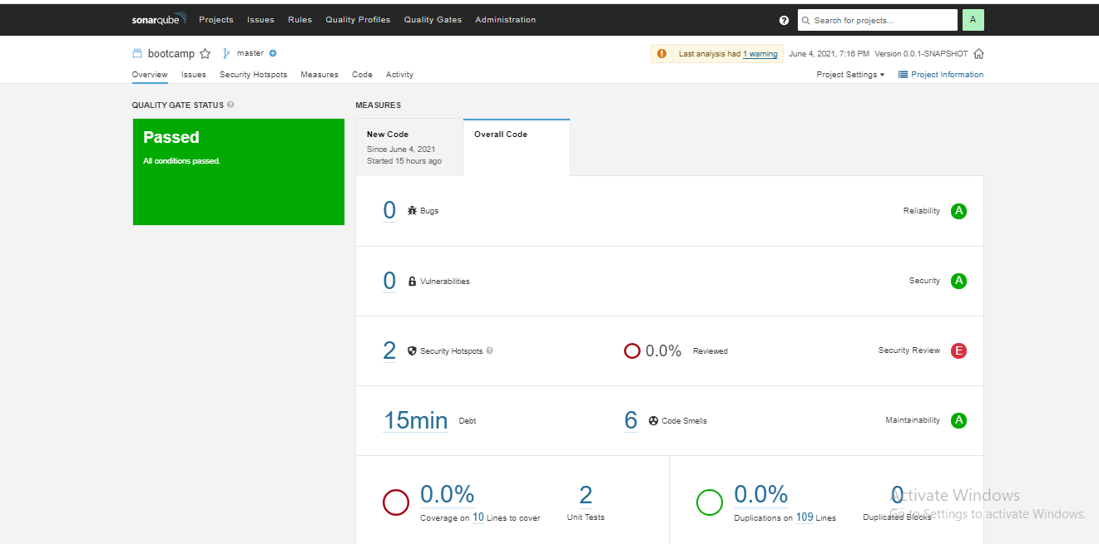

- Attach screenshot of the AppScan Report.

- Attach screenshot of your Ansible Playbook execution logs.

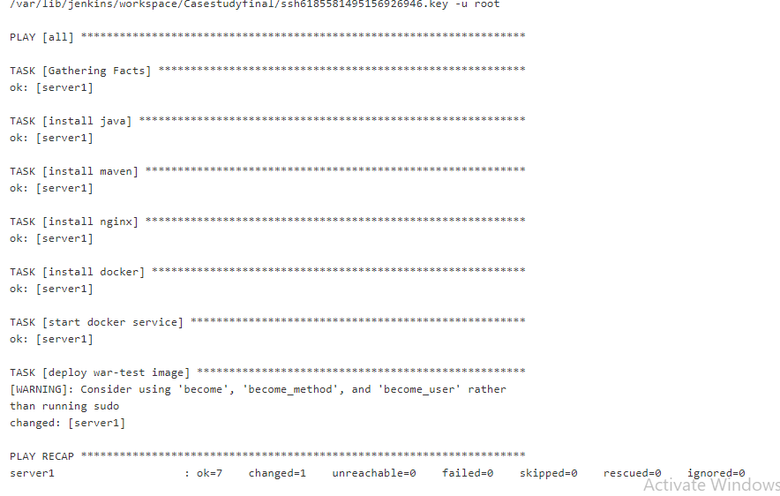

- Attach screenshot of the working application home page on AWS/GCP/Azure.

